Legal Description

Section 9, Township 28 South - Range 19 East Hillsborough County, Florida. All lands in the state of Florida are measured from the Tallahassee meridian in longitude 84° 16’ 59”. Commencing at the portion of the SW ¼, Section 9, Township 28, South - Range 19 East, run East 183.303 feet, thence run South 156.055 feet to the point of beginning. Thence, being said that along the N 05˚ 00’ 00’’ E bearing for 111.713 feet. Thence, the bearings at N 76˚ 04’ 24’’ E for 183.3025 feet to the boundary located on the west side of the Engineering Kopp buildings property lines. Thence, at the bearings of S 06˚ 12’ 20’ W is approximately 156.055 feet along said boundary line to the North right of way line of USF Blvd. located after the boundary to the west of bearing 05˚ 00’ 00’’. Thence, for bearing N 89˚ 56’ 37’’ W is for 170.440 feet along the North right of way to the initial point of commencing.

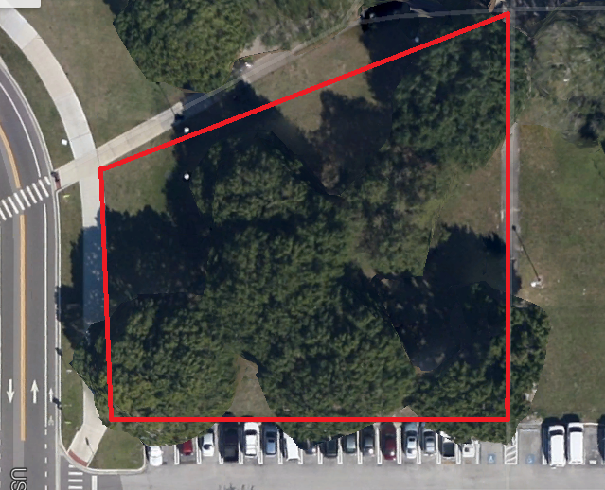
N 76® 04’ 24” E
183.303’
N 89® 56’ 37” E
170.440’
N 06® 12’ 20” E
156.055’
N 05® 00’ 00” E
111.713’

